Nama : Rosi Wijayanto
NIM : 23.01.55.7010

TUGAS WEB SERVICE MENGGUNAKAN POSTMAN

- Daftar Customers
http://localhost/php-crud-api/api.php/records/customers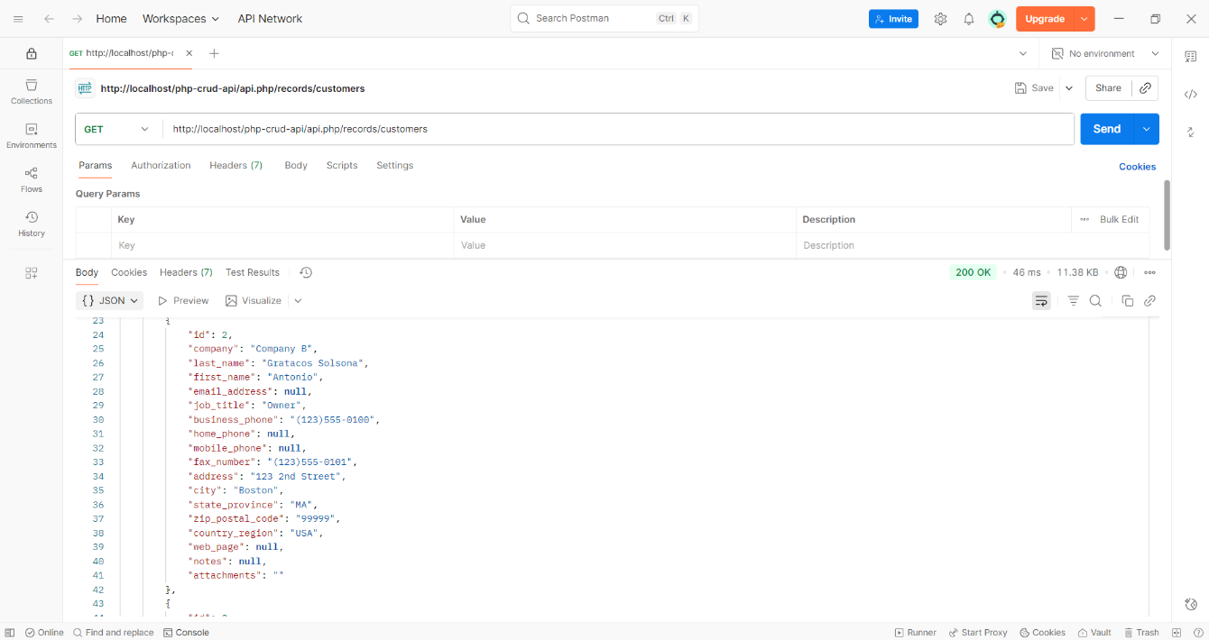

- Detail Customers
http://localhost/php-crud-api/api.php/records/customers/3
